AI vs Machine Learning vs Deep Learning

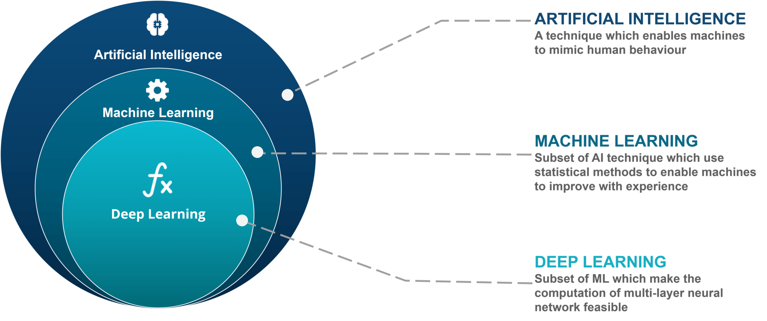

What is Artificial Intelligence?
Artificial Intelligence is a technique which allows the machines to act like humans by replicating their behaviour and nature.

What is Machine Learning?
Machine Learning is a subset of artificial intelligence. It allows the machines to learn and make predictions based on its experience (data).

What is Deep Learning?
Deep learning is a particular kind of machine learning that achieves great power and flexibility by learning to represent the world as nested hierarchy of concepts or abstraction.

Machine Learning
It is a type of AI that provides computers with the ability to learn without begin explicitly programmed.

Machine learning is a method of data analysis that automates analytical model building.

Using algorithms that iteratively learn from data, machine learning allows computers to find hidden insights without being explicitly programmed where to look.

Machine Learning Process
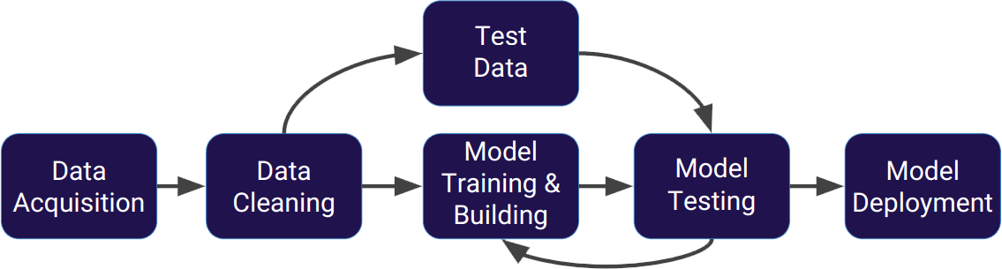

What is Algorithm?
Divide a process into small sub process to accomplish a particular task and to control the flow of that particular process.

Type of Algorithms:

1. Supervised Learning
2. Unsupervised Learning
3. Reinforcement Learning

Supervised Learning:
Supervised Learning is a type of algorithms in which computer is supervised by number of inputs and outputs.

Supervised learning algorithms are trained using labeled examples, such as an input where the desired output is known.
For example, a piece of equipment could have data points labeled either “F” (failed) or “R” (runs).

The learning algorithm receives a set of inputs along with the corresponding correct outputs, and the algorithm learns by comparing its actual output with correct outputs to find errors.
It then modifies the model accordingly.

Supervised learning is commonly used in applications where historical data predicts likely future events.

Type of Supervised Algorithms:

1. Classification- categorical output
2. Regression- continuous output

Unsupervised Learning:
Unsupervised Learning is a type of algorithms in which computer is governed by number of inputs. It is based on self-learning.
Clustering algorithms, pattern recognized in raw data.

Unsupervised learning is used against data that has no historical labels.

The system is not told the "right answer." The algorithm must figure out what is being shown.

The goal is to explore the data and find some structure within.

Reinforcement Learning:
Reinforcement Learning is a reward based algorithms in which computer takes decisions on previous experience.

Reinforcement learning is often used for robotics, gaming and navigation.

With reinforcement learning, the algorithm discovers through trial and error which actions yield the greatest rewards.

NumPy
NumPy (or Numpy) is a Linear Algebra Library for Python, the reason it is so important for Data Science with Python is that almost all of the libraries in the PyData Ecosystem rely on NumPy as one of their main building blocks.
Numpy is also incredibly fast, as it has bindings to C libraries.

Installation Instructions
It is highly recommended you install Python using the Anaconda distribution to make sure all underlying dependencies (such as Linear Algebra libraries) all sync up with the use of a conda install. If you have Anaconda, install NumPy by going to your terminal or command prompt and typing:
conda install numpy
pip install numpy

Using NumPy
Once you've installed NumPy you can import it as a library:
import numpy as np
Numpy has many built-in functions and capabilities.

Numpy Arrays
NumPy arrays are the main way we will use Numpy throughout the course.
Numpy arrays essentially come in two flavors:
vectors and matrices.
Vectors are strictly 1-d arrays and matrices are 2-d (but you should note a matrix can still have only one row or one column).

Creating NumPy Arrays

From a Python List
We can create an array by directly converting a list or list of lists:
my_list = [1,2,3]
my_list
[1, 2, 3]

np.array(my_list)
array([1, 2, 3])

my_matrix = [[1,2,3],[4,5,6],[7,8,9]]
my_matrix
[[1, 2, 3], [4, 5, 6], [7, 8, 9]]

np.array(my_matrix)
array([[1, 2, 3],
[4, 5, 6],
[7, 8, 9]])

Built-in Methods
There are lots of built-in ways to generate Arrays

arange
Return evenly spaced values within a given interval.

np.arange(0,10)
array([0, 1, 2, 3, 4, 5, 6, 7, 8, 9])

np.arange(0,11,2)
array([ 0, 2, 4, 6, 8, 10])

zeros and ones
Generate arrays of zeros or ones
np.zeros(3)
array([ 0., 0., 0.])

np.zeros((5,5))
array([[ 0., 0., 0., 0., 0.],
[ 0., 0., 0., 0., 0.],
[ 0., 0., 0., 0., 0.],
[ 0., 0., 0., 0., 0.],
[ 0., 0., 0., 0., 0.]])

np.ones(3)
array([ 1., 1., 1.])

np.ones((3,3))
array([[ 1., 1., 1.],
[ 1., 1., 1.],
[ 1., 1., 1.]])

linspace
Return evenly spaced numbers over a specified interval.

np.linspace(0,10,3)
array([ 0., 5., 10.])

np.linspace(0,10,50)
array([ 0. , 0.20408163, 0.40816327, 0.6122449 ,
0.81632653, 1.02040816, 1.2244898 , 1.42857143,
1.63265306, 1.83673469, 2.04081633, 2.24489796,
2.44897959, 2.65306122, 2.85714286, 3.06122449,
3.26530612, 3.46938776, 3.67346939, 3.87755102,
4.08163265, 4.28571429, 4.48979592, 4.69387755,
4.89795918, 5.10204082, 5.30612245, 5.51020408,
5.71428571, 5.91836735, 6.12244898, 6.32653061,
6.53061224, 6.73469388, 6.93877551, 7.14285714,
7.34693878, 7.55102041, 7.75510204, 7.95918367,
8.16326531, 8.36734694, 8.57142857, 8.7755102 ,
8.97959184, 9.18367347, 9.3877551 , 9.59183673,
9.79591837, 10. ])

eye
Creates an identity matrix
np.eye(4)
array([[ 1., 0., 0., 0.],
[ 0., 1., 0., 0.],
[ 0., 0., 1., 0.],
[ 0., 0., 0., 1.]])

Random
Numpy also has lots of ways to create random number arrays:

rand
Create an array of the given shape and populate it with random samples from a uniform distribution over [0, 1).

np.random.rand(2)
array([ 0.11570539, 0.35279769])

np.random.rand(5,5)
array([[ 0.66660768, 0.87589888, 0.12421056, 0.65074126, 0.60260888],
[ 0.70027668, 0.85572434, 0.8464595 , 0.2735416 , 0.10955384],
[ 0.0670566 , 0.83267738, 0.9082729 , 0.58249129, 0.12305748],
[ 0.27948423, 0.66422017, 0.95639833, 0.34238788, 0.9578872 ],
[ 0.72155386, 0.3035422 , 0.85249683, 0.30414307, 0.79718816]])

randn
Return a sample (or samples) from the "standard normal" distribution. Unlike rand which is uniform:

np.random.randn(2)
array([-0.27954018, 0.90078368])

np.random.randn(5,5)
array([[ 0.70154515, 0.22441999, 1.33563186, 0.82872577, -0.28247509],
[ 0.64489788, 0.61815094, -0.81693168, -0.30102424, -0.29030574],
[ 0.8695976 , 0.413755 , 2.20047208, 0.17955692, -0.82159344],
[ 0.59264235, 1.29869894, -1.18870241, 0.11590888, -0.09181687],
[-0.96924265, -1.62888685, -2.05787102, -0.29705576, 0.68915542]])

randint
Return random integers from low (inclusive) to high (exclusive).

np.random.randint(1,100)
44

np.random.randint(1,100,10)
array([13, 64, 27, 63, 46, 68, 92, 10, 58, 24])

Array Attributes and Methods
Let's discuss some useful attributes and methods or an array:
arr = np.arange(25)
ranarr = np.random.randint(0,50,10)
arr
array([ 0, 1, 2, 3, 4, 5, 6, 7, 8, 9, 10, 11, 12, 13, 14, 15, 16,
17, 18, 19, 20, 21, 22, 23, 24])
ranarr
array([10, 12, 41, 17, 49, 2, 46, 3, 19, 39])

Reshape
Returns an array containing the same data with a new shape.

arr.reshape(5,5)
array([[ 0, 1, 2, 3, 4],
[ 5, 6, 7, 8, 9],
[10, 11, 12, 13, 14],
[15, 16, 17, 18, 19],
[20, 21, 22, 23, 24]])

max,min,argmax,argmin
These are useful methods for finding max or min values. Or to find their index locations using argmin or argmax
ranarr=
array([10, 12, 41, 17, 49, 2, 46, 3, 19, 39])

ranarr.max()
49
ranarr.argmax()
4
ranarr.min()
2
ranarr.argmin()
5

Shape
Shape is an attribute that arrays have (not a method):

# Vector
arr.shape
(25,)

# Notice the two sets of brackets
arr.reshape(1,25)
array([[ 0, 1, 2, 3, 4, 5, 6, 7, 8, 9, 10, 11, 12, 13, 14, 15, 16,
17, 18, 19, 20, 21, 22, 23, 24]])

arr.reshape(1,25).shape
(1, 25)

arr.reshape(25,1)
array([[ 0],
[ 1],
[ 2],
[ 3],
[ 4],
[ 5],
[ 6],
[ 7],
[ 8],
[ 9],
[10],
[11],
[12],
[13],
[14],
[15],
[16],
[17],
[18],
[19],
[20],
[21],
[22],
[23],
[24]])

arr.reshape(25,1).shape
(25, 1)

dtype
You can also grab the data type of the object in the array:
arr.dtype
dtype('int64')

NumPy Indexing and Selection

#Creating sample array
arr = np.arange(0,11)

#Show
arr
array([ 0, 1, 2, 3, 4, 5, 6, 7, 8, 9, 10])

Bracket Indexing and Selection
The simplest way to pick one or some elements of an array looks very similar to python lists:
#Get a value at an index
arr[8]
8

#Get values in a range
arr[1:5]
array([1, 2, 3, 4])

#Get values in a range
arr[0:5]
array([0, 1, 2, 3, 4])

Broadcasting
Numpy arrays differ from a normal Python list because of their ability to broadcast:
#Setting a value with index range (Broadcasting)
arr[0:5]=100
​#Show
arr
array([100, 100, 100, 100, 100, 5, 6, 7, 8, 9, 10])

# Reset array, we'll see why I had to reset in a moment
arr = np.arange(0,11)
​#Show
arr
array([ 0, 1, 2, 3, 4, 5, 6, 7, 8, 9, 10])
#Important notes on Slices
slice_of_arr = arr[0:6]
​#Show slice
slice_of_arr
array([0, 1, 2, 3, 4, 5])

#Change Slice
slice_of_arr[:]=99
​
#Show Slice again
slice_of_arr
array([99, 99, 99, 99, 99, 99])

Now note the changes also occur in our original array!
arr
array([99, 99, 99, 99, 99, 99, 6, 7, 8, 9, 10])

Data is not copied, it's a view of the original array! This avoids memory problems!
#To get a copy, need to be explicit
arr_copy = arr.copy()
​arr_copy
array([99, 99, 99, 99, 99, 99, 6, 7, 8, 9, 10])

Indexing a 2D array (matrices)
The general format is arr_2d[row][col] or arr_2d[row,col]. I recommend usually using the comma notation for clarity.
arr_2d = np.array(([5,10,15],[20,25,30],[35,40,45]))
​arr_2d
array([[ 5, 10, 15],
[20, 25, 30],
[35, 40, 45]])

#Indexing row
arr_2d[1]
array([20, 25, 30])

# Format is arr_2d[row][col] or arr_2d[row,col]

# Getting individual element value
arr_2d[1][0]
20

# Getting individual element value
arr_2d[1,0]
20

# 2D array slicing
#Shape (2,2) from top right corner
arr_2d[:2,1:]
array([[10, 15],
[25, 30]])

#Shape bottom row
arr_2d[2]
array([35, 40, 45])

#Shape bottom row
arr_2d[2,:]
array([35, 40, 45])

NumPy Operations

Arithmetic
You can easily perform array with array arithmetic, or scalar with array arithmetic. Let's see some examples:
import numpy as np
arr = np.arange(0,10)

arr + arr
array([ 0, 2, 4, 6, 8, 10, 12, 14, 16, 18])
arr * arr
array([ 0, 1, 4, 9, 16, 25, 36, 49, 64, 81])
arr – arr
array([0, 0, 0, 0, 0, 0, 0, 0, 0, 0])
# Warning on division by zero, but not an error!
# Just replaced with nan
arr/arr
array([ nan, 1., 1., 1., 1., 1., 1., 1., 1., 1.])
# Also warning, but not an error instead infinity
1/arr
array([ inf, 1. , 0.5 , 0.33333333, 0.25 ,
0.2 , 0.16666667, 0.14285714, 0.125 , 0.11111111])
arr**3
array([ 0, 1, 8, 27, 64, 125, 216, 343, 512, 729])

Universal Array Functions
Numpy comes with many universal array functions, which are essentially just mathematical operations you can use to perform the operation across the array. Let's show some common ones:
#Taking Square Roots
np.sqrt(arr)
array([ 0. , 1. , 1.41421356, 1.73205081, 2. ,
2.23606798, 2.44948974, 2.64575131, 2.82842712, 3. ])
#Calcualting exponential (e^)
np.exp(arr)
array([ 1.00000000e+00, 2.71828183e+00, 7.38905610e+00,
2.00855369e+01, 5.45981500e+01, 1.48413159e+02,
4.03428793e+02, 1.09663316e+03, 2.98095799e+03,
8.10308393e+03])

np.max(arr) #same as arr.max()
9

np.sin(arr)
array([ 0. , 0.84147098, 0.90929743, 0.14112001, -0.7568025 ,
-0.95892427, -0.2794155 , 0.6569866 , 0.98935825, 0.41211849])

np.log(arr)
array([ -inf, 0. , 0.69314718, 1.09861229, 1.38629436,
1.60943791, 1.79175947, 1.94591015, 2.07944154, 2.19722458])

Simple Linear Regression
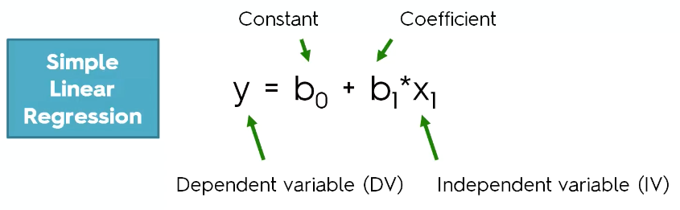
Simple linear regression is a statistical method that allows us to summarize and study relationships between two continuous (quantitative) variables.

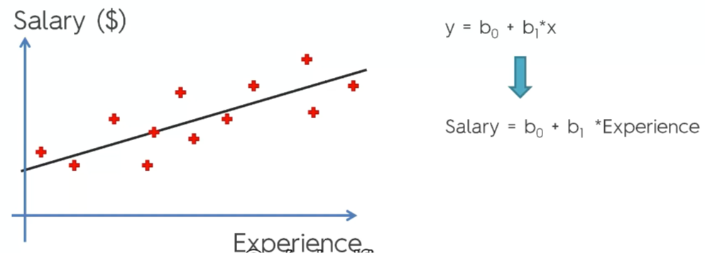

Ordinary Least Squares
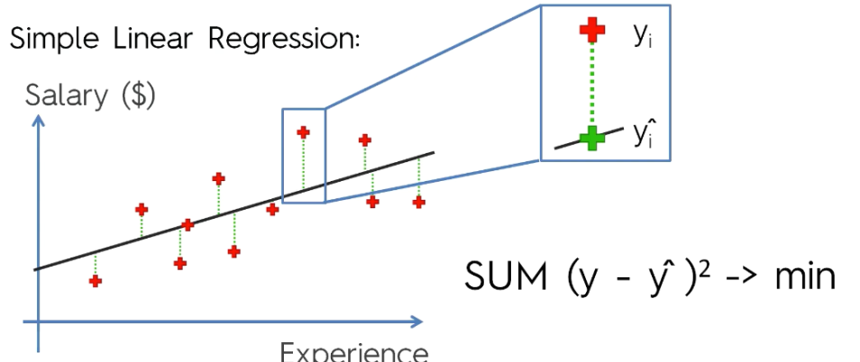

Building A Model

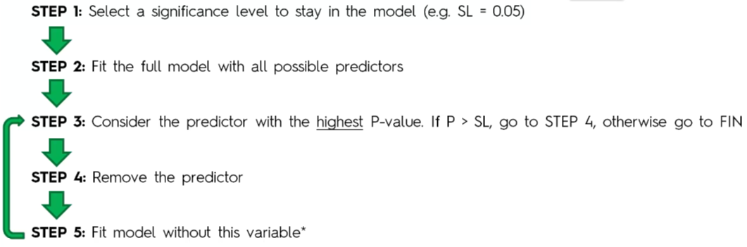

# Importing the libraries
import numpy as np
import matplotlib.pyplot as plt
import pandas as pd

# Importing the dataset
dataset = pd.read_csv('Salary_Data.csv')
X = dataset.iloc[:, :-1].values
y = dataset.iloc[:, 1].values

# Splitting the dataset into the Training set and Test set
from sklearn.model_selection import train_test_split
X_train, X_test, y_train, y_test = train_test_split(X, y, test_size = 1/3, random_state = 0)

# Feature Scaling
"""from sklearn.preprocessing import StandardScaler
sc_X = StandardScaler()
X_train = sc_X.fit_transform(X_train)
X_test = sc_X.transform(X_test)
sc_y = StandardScaler()
y_train = sc_y.fit_transform(y_train)"""

# Fitting Simple Linear Regression to the Training set
from sklearn.linear_model import LinearRegression
regressor = LinearRegression()
regressor.fit(X_train, y_train)

# Predicting the Test set results
y_pred = regressor.predict(X_test)

# Visualising the Training set results
plt.scatter(X_train, y_train, color = 'red')
plt.plot(X_train, regressor.predict(X_train), color = 'blue')
plt.title('Salary vs Experience (Training set)')
plt.xlabel('Years of Experience')
plt.ylabel('Salary')
plt.show()

# Visualising the Test set results
plt.scatter(X_test, y_test, color = 'red')
plt.plot(X_train, regressor.predict(X_train), color = 'blue')
plt.title('Salary vs Experience (Test set)')
plt.xlabel('Years of Experience')
plt.ylabel('Salary')
plt.show()

Multiple Linear Regression

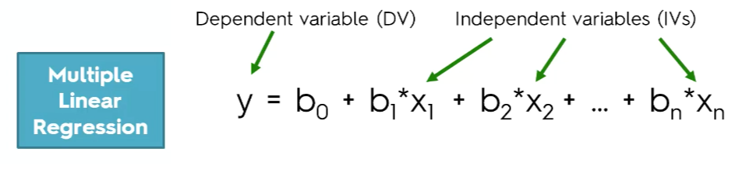
Dummy Variable
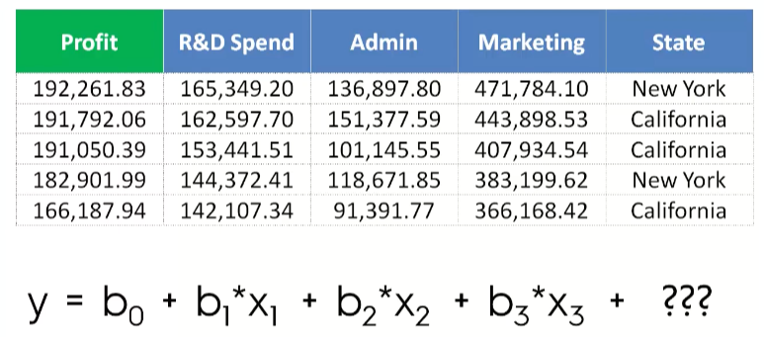
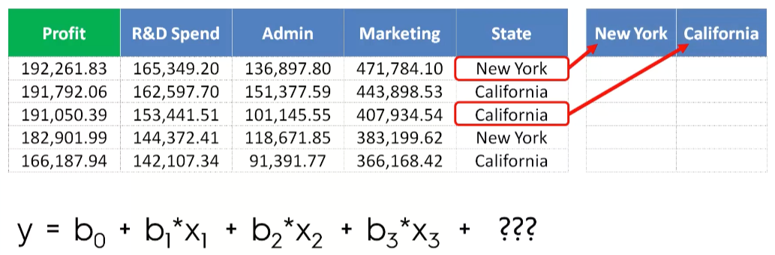
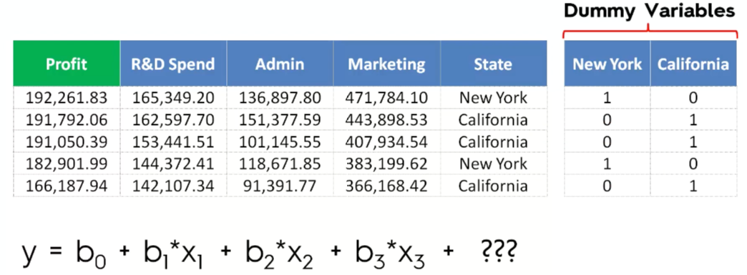
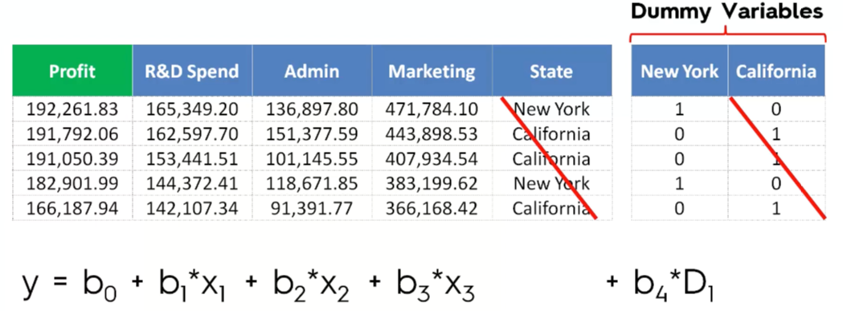
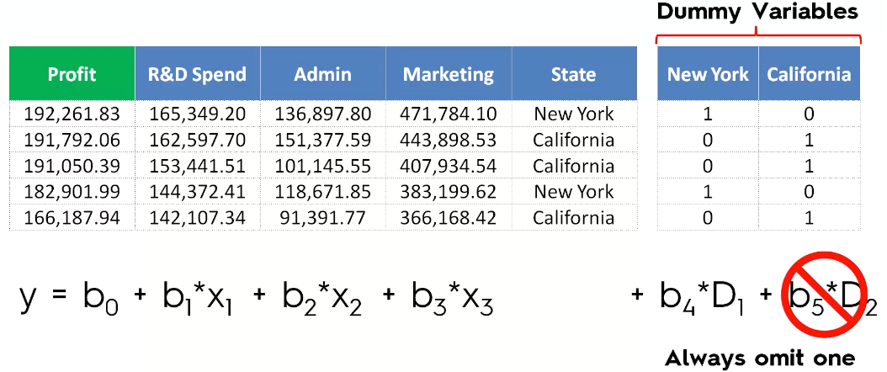
# Importing the libraries
import numpy as np
import matplotlib.pyplot as plt
import pandas as pd

# Importing the dataset
dataset = pd.read_csv('50_Startups.csv')
X = dataset.iloc[:, :-1].values
y = dataset.iloc[:, 4].values

# Encoding categorical data
from sklearn.preprocessing import LabelEncoder, OneHotEncoder
labelencoder = LabelEncoder()
X[:, 3] = labelencoder.fit_transform(X[:, 3])
onehotencoder = OneHotEncoder(categorical_features = [3])
X = onehotencoder.fit_transform(X).toarray()

# Avoiding the Dummy Variable Trap
X = X[:, 1:]

# Splitting the dataset into the Training set and Test set
from sklearn.model_selection import train_test_split
X_train, X_test, y_train, y_test = train_test_split(X, y, test_size = 0.2, random_state = 0)

# Fitting Multiple Linear Regression to the Training set
from sklearn.linear_model import LinearRegression
regressor = LinearRegression()
regressor.fit(X_train, y_train)

# Predicting the Test set results
y_pred = regressor.predict(X_test)

Multiple Linear Regression

# Importing the libraries
import numpy as np
import matplotlib.pyplot as plt
import pandas as pd

# Importing the dataset
dataset = pd.read_csv('50_Startups.csv')
X = dataset.iloc[:, :-1].values
y = dataset.iloc[:, 4].values

# Encoding categorical data
from sklearn.preprocessing import LabelEncoder, OneHotEncoder
labelencoder = LabelEncoder()
X[:, 3] = labelencoder.fit_transform(X[:, 3])
onehotencoder = OneHotEncoder(categorical_features = [3])
X = onehotencoder.fit_transform(X).toarray()

# Avoiding the Dummy Variable Trap
X = X[:, 1:]

# Splitting the dataset into the Training set and Test set
from sklearn.model_selection import train_test_split
X_train, X_test, y_train, y_test = train_test_split(X, y, test_size = 0.2, random_state = 0)

# Fitting Multiple Linear Regression to the Training set
from sklearn.linear_model import LinearRegression
regressor = LinearRegression()
regressor.fit(X_train, y_train)

# Predicting the Test set results
y_pred = regressor.predict(X_test)

# Building the optimal model using Backward Elimination
import statsmodels.formula.api as sm
X = np.append(arr = np.ones((50, 1)).astype(int), values = X, axis = 1)
X_opt = X[:, [0, 1, 2, 3, 4, 5]]
regressor_OLS = sm.OLS(endog = y, exog = X_opt).fit()
regressor_OLS.summary()
X_opt = X[:, [0, 1, 3, 4, 5]]
regressor_OLS = sm.OLS(endog = y, exog = X_opt).fit()
regressor_OLS.summary()
X_opt = X[:, [0, 3, 4, 5]]
regressor_OLS = sm.OLS(endog = y, exog = X_opt).fit()
regressor_OLS.summary()
X_opt = X[:, [0, 3, 5]]
regressor_OLS = sm.OLS(endog = y, exog = X_opt).fit()
regressor_OLS.summary()
X_opt = X[:, [0, 3]]
regressor_OLS = sm.OLS(endog = y, exog = X_opt).fit()
regressor_OLS.summary()

Polynomial Regression

# Importing the libraries
import numpy as np
import matplotlib.pyplot as plt
import pandas as pd

# Importing the dataset
dataset = pd.read_csv('Position_Salaries.csv')
X = dataset.iloc[:, 1:2].values
y = dataset.iloc[:, 2].values

# Splitting the dataset into the Training set and Test set
"""from sklearn.model_selection import train_test_split
X_train, X_test, y_train, y_test = train_test_split(X, y, test_size = 0.2, random_state = 0)"""

# Feature Scaling
"""from sklearn.preprocessing import StandardScaler
sc_X = StandardScaler()
X_train = sc_X.fit_transform(X_train)
X_test = sc_X.transform(X_test)"""

# Fitting Linear Regression to the dataset
from sklearn.linear_model import LinearRegression
lin_reg = LinearRegression()
lin_reg.fit(X, y)

# Fitting Polynomial Regression to the dataset
from sklearn.preprocessing import PolynomialFeatures
poly_reg = PolynomialFeatures(degree = 4)
X_poly = poly_reg.fit_transform(X)
poly_reg.fit(X_poly, y)
lin_reg_2 = LinearRegression()
lin_reg_2.fit(X_poly, y)

# Visualising the Linear Regression results
plt.scatter(X, y, color = 'red')
plt.plot(X, lin_reg.predict(X), color = 'blue')
plt.title('Truth or Bluff (Linear Regression)')
plt.xlabel('Position level')
plt.ylabel('Salary')
plt.show()

# Visualising the Polynomial Regression results
plt.scatter(X, y, color = 'red')
plt.plot(X, lin_reg_2.predict(poly_reg.fit_transform(X)), color = 'blue')
plt.title('Truth or Bluff (Polynomial Regression)')
plt.xlabel('Position level')
plt.ylabel('Salary')
plt.show()

# Visualising the Polynomial Regression results (for higher resolution and smoother curve)
X_grid = np.arange(min(X), max(X), 0.1)
X_grid = X_grid.reshape((len(X_grid), 1))
plt.scatter(X, y, color = 'red')
plt.plot(X_grid, lin_reg_2.predict(poly_reg.fit_transform(X_grid)), color = 'blue')
plt.title('Truth or Bluff (Polynomial Regression)')
plt.xlabel('Position level')
plt.ylabel('Salary')
plt.show()

# Predicting a new result with Linear Regression
lin_reg.predict(6.5)

# Predicting a new result with Polynomial Regression
lin_reg_2.predict(poly_reg.fit_transform(6.5))

Decision Tree Regression
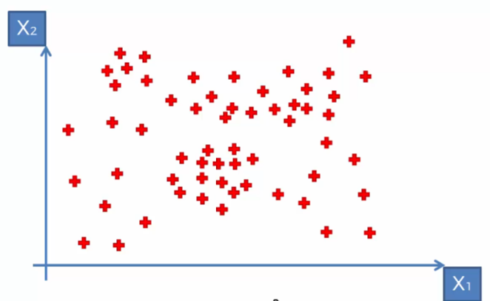
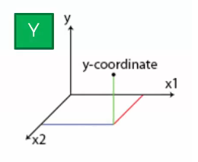
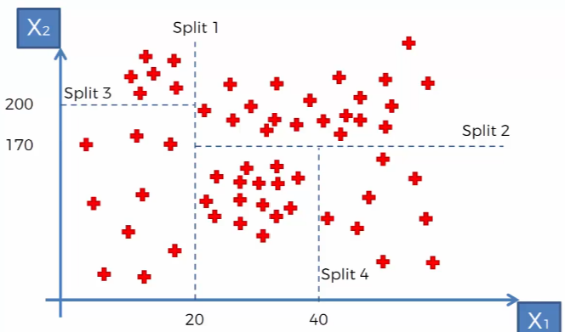

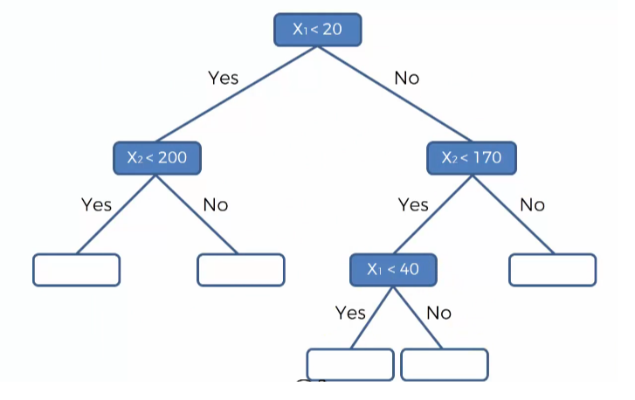
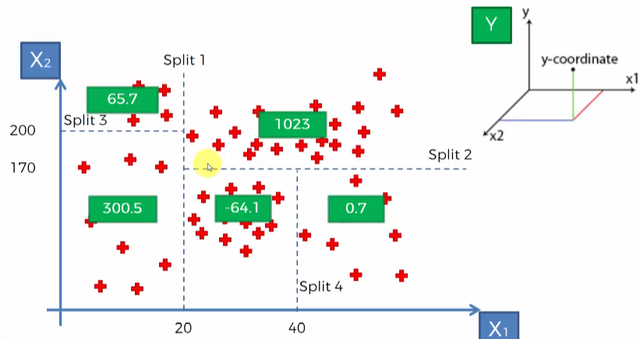

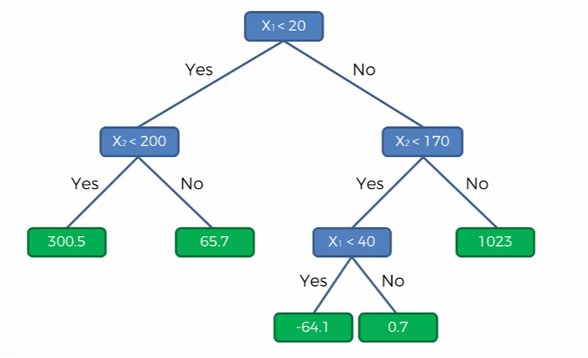
# Importing the libraries
import numpy as np
import matplotlib.pyplot as plt
import pandas as pd

# Importing the dataset
dataset = pd.read_csv('Position_Salaries.csv')
X = dataset.iloc[:, 1:2].values
y = dataset.iloc[:, 2].values

# Splitting the dataset into the Training set and Test set
"""from sklearn.model_selection import train_test_split
X_train, X_test, y_train, y_test = train_test_split(X, y, test_size = 0.2, random_state = 0)"""

# Feature Scaling
"""from sklearn.preprocessing import StandardScaler
sc_X = StandardScaler()
X_train = sc_X.fit_transform(X_train)
X_test = sc_X.transform(X_test)
sc_y = StandardScaler()
y_train = sc_y.fit_transform(y_train)"""

# Fitting Decision Tree Regression to the dataset
from sklearn.tree import DecisionTreeRegressor
regressor = DecisionTreeRegressor(random_state = 0)
regressor.fit(X, y)

# Predicting a new result
y_pred = regressor.predict(6.5)

# Visualising the Decision Tree Regression results (higher resolution)
X_grid = np.arange(min(X), max(X), 0.01)
X_grid = X_grid.reshape((len(X_grid), 1))
plt.scatter(X, y, color = 'red')
plt.plot(X_grid, regressor.predict(X_grid), color = 'blue')
plt.title('Truth or Bluff (Decision Tree Regression)')
plt.xlabel('Position level')
plt.ylabel('Salary')
plt.show()

Random Forest Regression

Ensemble Learning
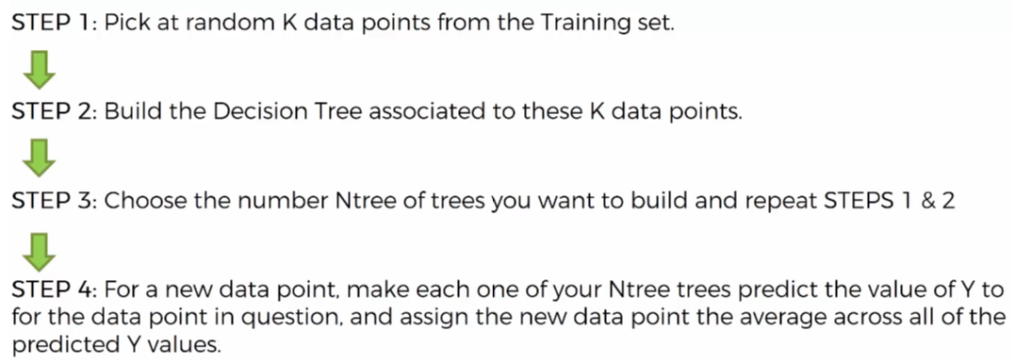

# Importing the libraries
import numpy as np
import matplotlib.pyplot as plt
import pandas as pd

# Importing the dataset
dataset = pd.read_csv('Position_Salaries.csv')
X = dataset.iloc[:, 1:2].values
y = dataset.iloc[:, 2].values

# Splitting the dataset into the Training set and Test set
"""from sklearn.model_selection import train_test_split
X_train, X_test, y_train, y_test = train_test_split(X, y, test_size = 0.2, random_state = 0)"""

# Feature Scaling
"""from sklearn.preprocessing import StandardScaler
sc_X = StandardScaler()
X_train = sc_X.fit_transform(X_train)
X_test = sc_X.transform(X_test)
sc_y = StandardScaler()
y_train = sc_y.fit_transform(y_train)"""

# Fitting Random Forest Regression to the dataset
from sklearn.ensemble import RandomForestRegressor
regressor = RandomForestRegressor(n_estimators = 10, random_state = 0)
regressor.fit(X, y)

# Predicting a new result
y_pred = regressor.predict(6.5)

# Visualising the Random Forest Regression results (higher resolution)
X_grid = np.arange(min(X), max(X), 0.01)
X_grid = X_grid.reshape((len(X_grid), 1))
plt.scatter(X, y, color = 'red')
plt.plot(X_grid, regressor.predict(X_grid), color = 'blue')
plt.title('Truth or Bluff (Random Forest Regression)')
plt.xlabel('Position level')
plt.ylabel('Salary')
plt.show()

Logistic Regression

We want to learn about Logistic Regression as a method for Classification.
Some examples of classification problems:
- Spam versus “Ham” emails
- Loan Default (yes/no)
- Disease Diagnosis
Above were all examples of Binary Classification

So far we’ve only seen regression problems where we try to predict a continuous value.

Although the name may be confusing at first, logistic regression allows us to solve classification problems, where we are trying to predict discrete categories.

The convention for binary classification is to have two classes 0 and 1.

We can’t use a normal linear regression model on binary groups. It won’t lead to a good fit:
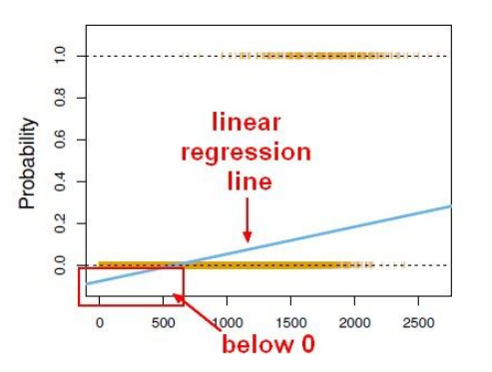
Instead we can transform our linear regression to a logistic regression curve.
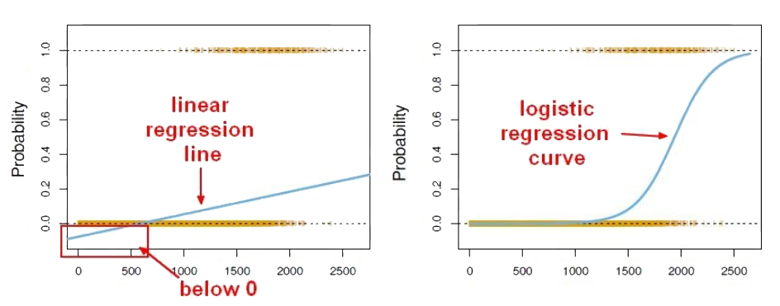
Sigmoid Function
The Sigmoid (aka Logistic) Function takes in any value and outputs it to be between 0 and 1.
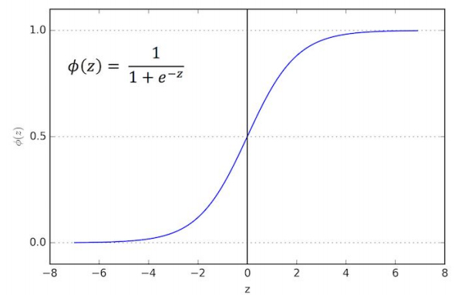
This means we can take our Linear Regression Solution and place it into the Sigmoid Function.

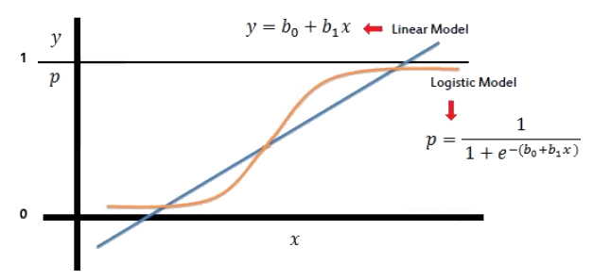
This results in a probability from 0 to 1 of belonging in the 1 class.
We can set a cutoff point at 0.5, anything below it results in class 0, anything above is class 1

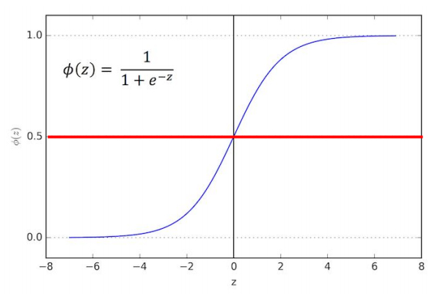
Model Evaluation
- After you train a logistic regression model on some training data, you will evaluate your model’s performance on some test data.
- You can use a confusion matrix to evaluate classification models.
- We can use a confusion matrix to evaluate our model.
- For example, imagine testing for disease.
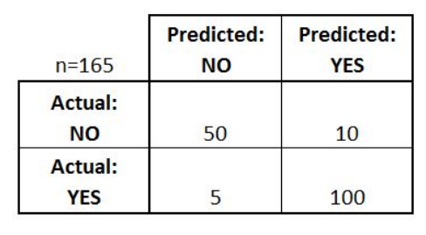
Example:
- Test for presence of NO = negative test = False = 0 YES = positive test = True = 1

Confusion Matrix
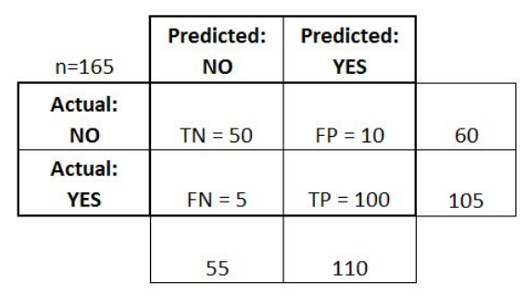

Basic Terminology:
- True Positives (TP)
- True Negatives (TN)
- False Positives (FP)
- False Negatives (FN)

Basic Terminology:
- Overall, how often is it correct?
- Each (TP + TN) / total = 150/165 = 0.91

Misclassification Rate (Error Rate):
- Overall, how often is it wrong?
- (FP + FN) / total = 15/165 = 0.09

# Importing the libraries
import numpy as np
import matplotlib.pyplot as plt
import pandas as pd

# Importing the dataset
dataset = pd.read_csv('Social_Network_Ads.csv')
X = dataset.iloc[:, [2, 3]].values
y = dataset.iloc[:, 4].values

# Splitting the dataset into the Training set and Test set
from sklearn.model_selection import train_test_split
X_train, X_test, y_train, y_test = train_test_split(X, y, test_size = 0.25, random_state = 0)

# Feature Scaling
from sklearn.preprocessing import StandardScaler
sc = StandardScaler()
X_train = sc.fit_transform(X_train)
X_test = sc.transform(X_test)

# Fitting Logistic Regression to the Training set
from sklearn.linear_model import LogisticRegression
classifier = LogisticRegression(random_state = 0)
classifier.fit(X_train, y_train)

# Predicting the Test set results
y_pred = classifier.predict(X_test)

# Making the Confusion Matrix
from sklearn.metrics import confusion_matrix
cm = confusion_matrix(y_test, y_pred)

# Visualising the Training set results
from matplotlib.colors import ListedColormap
X_set, y_set = X_train, y_train
X1, X2 = np.meshgrid(np.arange(start = X_set[:, 0].min() - 1, stop = X_set[:, 0].max() + 1, step = 0.01),
np.arange(start = X_set[:, 1].min() - 1, stop = X_set[:, 1].max() + 1, step = 0.01))
plt.contourf(X1, X2, classifier.predict(np.array([X1.ravel(), X2.ravel()]).T).reshape(X1.shape),
alpha = 0.75, cmap = ListedColormap(('red', 'green')))
plt.xlim(X1.min(), X1.max())
plt.ylim(X2.min(), X2.max())
for i, j in enumerate(np.unique(y_set)):
plt.scatter(X_set[y_set == j, 0], X_set[y_set == j, 1],
c = ListedColormap(('red', 'green'))(i), label = j)
plt.title('Logistic Regression (Training set)')
plt.xlabel('Age')
plt.ylabel('Estimated Salary')
plt.legend()
plt.show()

# Visualising the Test set results
from matplotlib.colors import ListedColormap
X_set, y_set = X_test, y_test
X1, X2 = np.meshgrid(np.arange(start = X_set[:, 0].min() - 1, stop = X_set[:, 0].max() + 1, step = 0.01),
np.arange(start = X_set[:, 1].min() - 1, stop = X_set[:, 1].max() + 1, step = 0.01))
plt.contourf(X1, X2, classifier.predict(np.array([X1.ravel(), X2.ravel()]).T).reshape(X1.shape),
alpha = 0.75, cmap = ListedColormap(('red', 'green')))
plt.xlim(X1.min(), X1.max())
plt.ylim(X2.min(), X2.max())
for i, j in enumerate(np.unique(y_set)):
plt.scatter(X_set[y_set == j, 0], X_set[y_set == j, 1],
c = ListedColormap(('red', 'green'))(i), label = j)
plt.title('Logistic Regression (Test set)')
plt.xlabel('Age')
plt.ylabel('Estimated Salary')
plt.legend()
plt.show()

Introduction to K Nearest Neighbors

K Nearest Neighbors is a classification algorithm that operates on a very simple principle.
It is best shown through example!
Imagine we had some imaginary data on Dogs and Horses, with heights and weights.
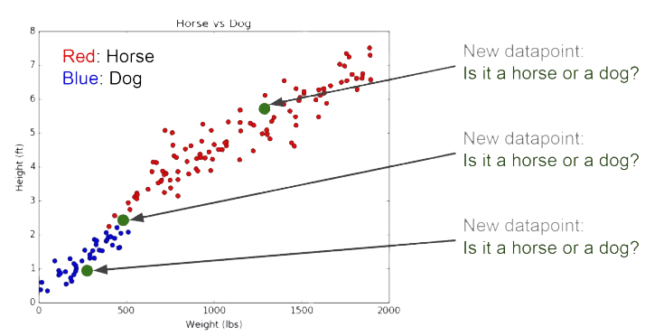
Training Algorithm:
1.Store all the Data

Prediction Algorithm:
1.Calculate the distance from x to all points in your data
2.Sort the points in your data by increasing distance from x
3.Predict the majority label of the “k” closest points

Choosing a K will affect what class a new point is assigned to:
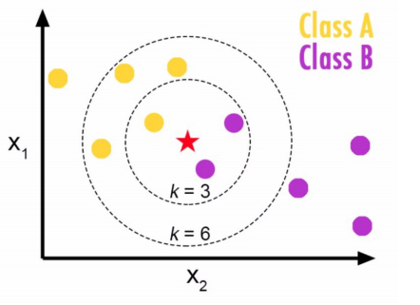

Choosing a K will affect what class a new point is assigned to:
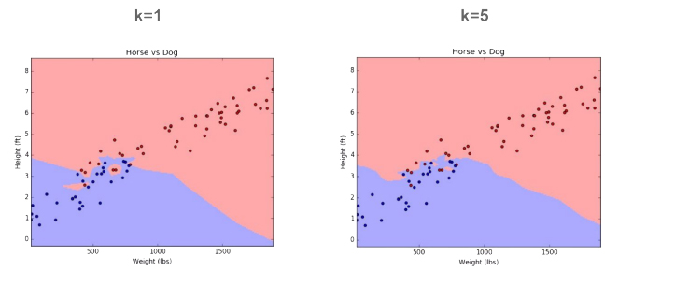
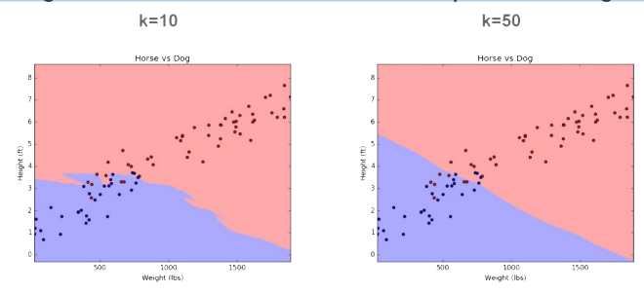
Pros
- Very simple
- Training is trivial
- Works with any number of classes
- Easy to add more data
- Few parameters
- K
- Distance Metric

Cons
- High Prediction Cost (worse for large data sets)
- Not good with high dimensional data
- Categorical Features don’t work well

K-Nearest Neighbors (K-NN)

# Importing the libraries
import numpy as np
import matplotlib.pyplot as plt
import pandas as pd

# Importing the dataset
dataset = pd.read_csv('Social_Network_Ads.csv')
X = dataset.iloc[:, [2, 3]].values
y = dataset.iloc[:, 4].values

# Splitting the dataset into the Training set and Test set
from sklearn.model_selection import train_test_split
X_train, X_test, y_train, y_test = train_test_split(X, y, test_size = 0.25, random_state = 0)

# Feature Scaling
from sklearn.preprocessing import StandardScaler
sc = StandardScaler()
X_train = sc.fit_transform(X_train)
X_test = sc.transform(X_test)

# Fitting K-NN to the Training set
from sklearn.neighbors import KNeighborsClassifier
classifier = KNeighborsClassifier(n_neighbors = 5, metric = 'minkowski', p = 2)
classifier.fit(X_train, y_train)

# Predicting the Test set results
y_pred = classifier.predict(X_test)

# Making the Confusion Matrix
from sklearn.metrics import confusion_matrix
cm = confusion_matrix(y_test, y_pred)

# Visualising the Training set results
from matplotlib.colors import ListedColormap
X_set, y_set = X_train, y_train
X1, X2 = np.meshgrid(np.arange(start = X_set[:, 0].min() - 1, stop = X_set[:, 0].max() + 1, step = 0.01),
np.arange(start = X_set[:, 1].min() - 1, stop = X_set[:, 1].max() + 1, step = 0.01))
plt.contourf(X1, X2, classifier.predict(np.array([X1.ravel(), X2.ravel()]).T).reshape(X1.shape),
alpha = 0.75, cmap = ListedColormap(('red', 'green')))
plt.xlim(X1.min(), X1.max())
plt.ylim(X2.min(), X2.max())
for i, j in enumerate(np.unique(y_set)):
plt.scatter(X_set[y_set == j, 0], X_set[y_set == j, 1],
c = ListedColormap(('red', 'green'))(i), label = j)
plt.title('K-NN (Training set)')
plt.xlabel('Age')
plt.ylabel('Estimated Salary')
plt.legend()
plt.show()

# Visualising the Test set results
from matplotlib.colors import ListedColormap
X_set, y_set = X_test, y_test
X1, X2 = np.meshgrid(np.arange(start = X_set[:, 0].min() - 1, stop = X_set[:, 0].max() + 1, step = 0.01),
np.arange(start = X_set[:, 1].min() - 1, stop = X_set[:, 1].max() + 1, step = 0.01))
plt.contourf(X1, X2, classifier.predict(np.array([X1.ravel(), X2.ravel()]).T).reshape(X1.shape),
alpha = 0.75, cmap = ListedColormap(('red', 'green')))
plt.xlim(X1.min(), X1.max())
plt.ylim(X2.min(), X2.max())
for i, j in enumerate(np.unique(y_set)):
plt.scatter(X_set[y_set == j, 0], X_set[y_set == j, 1],
c = ListedColormap(('red', 'green'))(i), label = j)
plt.title('K-NN (Test set)')
plt.xlabel('Age')
plt.ylabel('Estimated Salary')
plt.legend()
plt.show()

Decision Tree Classification

# Importing the libraries
import numpy as np
import matplotlib.pyplot as plt
import pandas as pd

# Importing the dataset
dataset = pd.read_csv('Social_Network_Ads.csv')
X = dataset.iloc[:, [2, 3]].values
y = dataset.iloc[:, 4].values

# Splitting the dataset into the Training set and Test set
from sklearn.model_selection import train_test_split
X_train, X_test, y_train, y_test = train_test_split(X, y, test_size = 0.25, random_state = 0)

# Feature Scaling
from sklearn.preprocessing import StandardScaler
sc = StandardScaler()
X_train = sc.fit_transform(X_train)
X_test = sc.transform(X_test)

# Fitting Decision Tree Classification to the Training set
from sklearn.tree import DecisionTreeClassifier
classifier = DecisionTreeClassifier(criterion = 'entropy', random_state = 0)
classifier.fit(X_train, y_train)

# Predicting the Test set results
y_pred = classifier.predict(X_test)

# Making the Confusion Matrix
from sklearn.metrics import confusion_matrix
cm = confusion_matrix(y_test, y_pred)

# Visualising the Training set results
from matplotlib.colors import ListedColormap
X_set, y_set = X_train, y_train
X1, X2 = np.meshgrid(np.arange(start = X_set[:, 0].min() - 1, stop = X_set[:, 0].max() + 1, step = 0.01),
np.arange(start = X_set[:, 1].min() - 1, stop = X_set[:, 1].max() + 1, step = 0.01))
plt.contourf(X1, X2, classifier.predict(np.array([X1.ravel(), X2.ravel()]).T).reshape(X1.shape),
alpha = 0.75, cmap = ListedColormap(('red', 'green')))
plt.xlim(X1.min(), X1.max())
plt.ylim(X2.min(), X2.max())
for i, j in enumerate(np.unique(y_set)):
plt.scatter(X_set[y_set == j, 0], X_set[y_set == j, 1],
c = ListedColormap(('red', 'green'))(i), label = j)
plt.title('Decision Tree Classification (Training set)')
plt.xlabel('Age')
plt.ylabel('Estimated Salary')
plt.legend()
plt.show()

# Visualising the Test set results
from matplotlib.colors import ListedColormap
X_set, y_set = X_test, y_test
X1, X2 = np.meshgrid(np.arange(start = X_set[:, 0].min() - 1, stop = X_set[:, 0].max() + 1, step = 0.01),
np.arange(start = X_set[:, 1].min() - 1, stop = X_set[:, 1].max() + 1, step = 0.01))
plt.contourf(X1, X2, classifier.predict(np.array([X1.ravel(), X2.ravel()]).T).reshape(X1.shape),
alpha = 0.75, cmap = ListedColormap(('red', 'green')))
plt.xlim(X1.min(), X1.max())
plt.ylim(X2.min(), X2.max())
for i, j in enumerate(np.unique(y_set)):
plt.scatter(X_set[y_set == j, 0], X_set[y_set == j, 1],
c = ListedColormap(('red', 'green'))(i), label = j)
plt.title('Decision Tree Classification (Test set)')
plt.xlabel('Age')
plt.ylabel('Estimated Salary')
plt.legend()
plt.show()

Random Forest Classification

# Importing the libraries
import numpy as np
import matplotlib.pyplot as plt
import pandas as pd

# Importing the dataset
dataset = pd.read_csv('Social_Network_Ads.csv')
X = dataset.iloc[:, [2, 3]].values
y = dataset.iloc[:, 4].values

# Splitting the dataset into the Training set and Test set
from sklearn.model_selection import train_test_split
X_train, X_test, y_train, y_test = train_test_split(X, y, test_size = 0.25, random_state = 0)

# Feature Scaling
from sklearn.preprocessing import StandardScaler
sc = StandardScaler()
X_train = sc.fit_transform(X_train)
X_test = sc.transform(X_test)

# Fitting Random Forest Classification to the Training set
from sklearn.ensemble import RandomForestClassifier
classifier = RandomForestClassifier(n_estimators = 10, criterion = 'entropy', random_state = 0)
classifier.fit(X_train, y_train)

# Predicting the Test set results
y_pred = classifier.predict(X_test)

# Making the Confusion Matrix
from sklearn.metrics import confusion_matrix
cm = confusion_matrix(y_test, y_pred)

# Visualising the Training set results
from matplotlib.colors import ListedColormap
X_set, y_set = X_train, y_train
X1, X2 = np.meshgrid(np.arange(start = X_set[:, 0].min() - 1, stop = X_set[:, 0].max() + 1, step = 0.01),
np.arange(start = X_set[:, 1].min() - 1, stop = X_set[:, 1].max() + 1, step = 0.01))
plt.contourf(X1, X2, classifier.predict(np.array([X1.ravel(), X2.ravel()]).T).reshape(X1.shape),
alpha = 0.75, cmap = ListedColormap(('red', 'green')))
plt.xlim(X1.min(), X1.max())
plt.ylim(X2.min(), X2.max())
for i, j in enumerate(np.unique(y_set)):
plt.scatter(X_set[y_set == j, 0], X_set[y_set == j, 1],
c = ListedColormap(('red', 'green'))(i), label = j)
plt.title('Random Forest Classification (Training set)')
plt.xlabel('Age')
plt.ylabel('Estimated Salary')
plt.legend()
plt.show()

# Visualising the Test set results
from matplotlib.colors import ListedColormap
X_set, y_set = X_test, y_test
X1, X2 = np.meshgrid(np.arange(start = X_set[:, 0].min() - 1, stop = X_set[:, 0].max() + 1, step = 0.01),
np.arange(start = X_set[:, 1].min() - 1, stop = X_set[:, 1].max() + 1, step = 0.01))
plt.contourf(X1, X2, classifier.predict(np.array([X1.ravel(), X2.ravel()]).T).reshape(X1.shape),
alpha = 0.75, cmap = ListedColormap(('red', 'green')))
plt.xlim(X1.min(), X1.max())
plt.ylim(X2.min(), X2.max())
for i, j in enumerate(np.unique(y_set)):
plt.scatter(X_set[y_set == j, 0], X_set[y_set == j, 1],
c = ListedColormap(('red', 'green'))(i), label = j)
plt.title('Random Forest Classification (Test set)')
plt.xlabel('Age')
plt.ylabel('Estimated Salary')
plt.legend()
plt.show()

Support Vector Machine (SVM)

# Importing the libraries
import numpy as np
import matplotlib.pyplot as plt
import pandas as pd

# Importing the dataset
dataset = pd.read_csv('Social_Network_Ads.csv')
X = dataset.iloc[:, [2, 3]].values
y = dataset.iloc[:, 4].values

# Splitting the dataset into the Training set and Test set
from sklearn.model_selection import train_test_split
X_train, X_test, y_train, y_test = train_test_split(X, y, test_size = 0.25, random_state = 0)

# Feature Scaling
from sklearn.preprocessing import StandardScaler
sc = StandardScaler()
X_train = sc.fit_transform(X_train)
X_test = sc.transform(X_test)

# Fitting SVM to the Training set
from sklearn.svm import SVC
classifier = SVC(kernel = 'linear', random_state = 0)
classifier.fit(X_train, y_train)

# Predicting the Test set results
y_pred = classifier.predict(X_test)

# Making the Confusion Matrix
from sklearn.metrics import confusion_matrix
cm = confusion_matrix(y_test, y_pred)

# Visualising the Training set results
from matplotlib.colors import ListedColormap
X_set, y_set = X_train, y_train
X1, X2 = np.meshgrid(np.arange(start = X_set[:, 0].min() - 1, stop = X_set[:, 0].max() + 1, step = 0.01),
np.arange(start = X_set[:, 1].min() - 1, stop = X_set[:, 1].max() + 1, step = 0.01))
plt.contourf(X1, X2, classifier.predict(np.array([X1.ravel(), X2.ravel()]).T).reshape(X1.shape),
alpha = 0.75, cmap = ListedColormap(('red', 'green')))
plt.xlim(X1.min(), X1.max())
plt.ylim(X2.min(), X2.max())
for i, j in enumerate(np.unique(y_set)):
plt.scatter(X_set[y_set == j, 0], X_set[y_set == j, 1],
c = ListedColormap(('red', 'green'))(i), label = j)
plt.title('SVM (Training set)')
plt.xlabel('Age')
plt.ylabel('Estimated Salary')
plt.legend()
plt.show()

# Visualising the Test set results
from matplotlib.colors import ListedColormap
X_set, y_set = X_test, y_test
X1, X2 = np.meshgrid(np.arange(start = X_set[:, 0].min() - 1, stop = X_set[:, 0].max() + 1, step = 0.01),
np.arange(start = X_set[:, 1].min() - 1, stop = X_set[:, 1].max() + 1, step = 0.01))
plt.contourf(X1, X2, classifier.predict(np.array([X1.ravel(), X2.ravel()]).T).reshape(X1.shape),
alpha = 0.75, cmap = ListedColormap(('red', 'green')))
plt.xlim(X1.min(), X1.max())
plt.ylim(X2.min(), X2.max())
for i, j in enumerate(np.unique(y_set)):
plt.scatter(X_set[y_set == j, 0], X_set[y_set == j, 1],
c = ListedColormap(('red', 'green'))(i), label = j)
plt.title('SVM (Test set)')
plt.xlabel('Age')
plt.ylabel('Estimated Salary')
plt.legend()
plt.show()

Kernel SVM

# Importing the libraries
import numpy as np
import matplotlib.pyplot as plt
import pandas as pd

# Importing the dataset
dataset = pd.read_csv('Social_Network_Ads.csv')
X = dataset.iloc[:, [2, 3]].values
y = dataset.iloc[:, 4].values

# Splitting the dataset into the Training set and Test set
from sklearn.model_selection import train_test_split
X_train, X_test, y_train, y_test = train_test_split(X, y, test_size = 0.25, random_state = 0)

# Feature Scaling
from sklearn.preprocessing import StandardScaler
sc = StandardScaler()
X_train = sc.fit_transform(X_train)
X_test = sc.transform(X_test)

# Fitting Kernel SVM to the Training set
from sklearn.svm import SVC
classifier = SVC(kernel = 'rbf', random_state = 0)
classifier.fit(X_train, y_train)

# Predicting the Test set results
y_pred = classifier.predict(X_test)

# Making the Confusion Matrix
from sklearn.metrics import confusion_matrix
cm = confusion_matrix(y_test, y_pred)

# Visualising the Training set results
from matplotlib.colors import ListedColormap
X_set, y_set = X_train, y_train
X1, X2 = np.meshgrid(np.arange(start = X_set[:, 0].min() - 1, stop = X_set[:, 0].max() + 1, step = 0.01),
np.arange(start = X_set[:, 1].min() - 1, stop = X_set[:, 1].max() + 1, step = 0.01))
plt.contourf(X1, X2, classifier.predict(np.array([X1.ravel(), X2.ravel()]).T).reshape(X1.shape),
alpha = 0.75, cmap = ListedColormap(('red', 'green')))
plt.xlim(X1.min(), X1.max())
plt.ylim(X2.min(), X2.max())
for i, j in enumerate(np.unique(y_set)):
plt.scatter(X_set[y_set == j, 0], X_set[y_set == j, 1],
c = ListedColormap(('red', 'green'))(i), label = j)
plt.title('Kernel SVM (Training set)')
plt.xlabel('Age')
plt.ylabel('Estimated Salary')
plt.legend()
plt.show()

# Visualising the Test set results
from matplotlib.colors import ListedColormap
X_set, y_set = X_test, y_test
X1, X2 = np.meshgrid(np.arange(start = X_set[:, 0].min() - 1, stop = X_set[:, 0].max() + 1, step = 0.01),
np.arange(start = X_set[:, 1].min() - 1, stop = X_set[:, 1].max() + 1, step = 0.01))
plt.contourf(X1, X2, classifier.predict(np.array([X1.ravel(), X2.ravel()]).T).reshape(X1.shape),
alpha = 0.75, cmap = ListedColormap(('red', 'green')))
plt.xlim(X1.min(), X1.max())
plt.ylim(X2.min(), X2.max())
for i, j in enumerate(np.unique(y_set)):
plt.scatter(X_set[y_set == j, 0], X_set[y_set == j, 1],
c = ListedColormap(('red', 'green'))(i), label = j)
plt.title('Kernel SVM (Test set)')
plt.xlabel('Age')
plt.ylabel('Estimated Salary')
plt.legend()
plt.show()

Naive Bayes

# Importing the libraries
import numpy as np
import matplotlib.pyplot as plt
import pandas as pd

# Importing the dataset
dataset = pd.read_csv('Social_Network_Ads.csv')
X = dataset.iloc[:, [2, 3]].values
y = dataset.iloc[:, 4].values

# Splitting the dataset into the Training set and Test set
from sklearn.model_selection import train_test_split
X_train, X_test, y_train, y_test = train_test_split(X, y, test_size = 0.25, random_state = 0)

# Feature Scaling
from sklearn.preprocessing import StandardScaler
sc = StandardScaler()
X_train = sc.fit_transform(X_train)
X_test = sc.transform(X_test)

# Fitting Naive Bayes to the Training set
from sklearn.naive_bayes import GaussianNB
classifier = GaussianNB()
classifier.fit(X_train, y_train)

# Predicting the Test set results
y_pred = classifier.predict(X_test)

# Making the Confusion Matrix
from sklearn.metrics import confusion_matrix
cm = confusion_matrix(y_test, y_pred)

# Visualising the Training set results
from matplotlib.colors import ListedColormap
X_set, y_set = X_train, y_train
X1, X2 = np.meshgrid(np.arange(start = X_set[:, 0].min() - 1, stop = X_set[:, 0].max() + 1, step = 0.01),
np.arange(start = X_set[:, 1].min() - 1, stop = X_set[:, 1].max() + 1, step = 0.01))
plt.contourf(X1, X2, classifier.predict(np.array([X1.ravel(), X2.ravel()]).T).reshape(X1.shape),
alpha = 0.75, cmap = ListedColormap(('red', 'green')))
plt.xlim(X1.min(), X1.max())
plt.ylim(X2.min(), X2.max())
for i, j in enumerate(np.unique(y_set)):
plt.scatter(X_set[y_set == j, 0], X_set[y_set == j, 1],
c = ListedColormap(('red', 'green'))(i), label = j)
plt.title('Naive Bayes (Training set)')
plt.xlabel('Age')
plt.ylabel('Estimated Salary')
plt.legend()
plt.show()

# Visualising the Test set results
from matplotlib.colors import ListedColormap
X_set, y_set = X_test, y_test
X1, X2 = np.meshgrid(np.arange(start = X_set[:, 0].min() - 1, stop = X_set[:, 0].max() + 1, step = 0.01),
np.arange(start = X_set[:, 1].min() - 1, stop = X_set[:, 1].max() + 1, step = 0.01))
plt.contourf(X1, X2, classifier.predict(np.array([X1.ravel(), X2.ravel()]).T).reshape(X1.shape),
alpha = 0.75, cmap = ListedColormap(('red', 'green')))
plt.xlim(X1.min(), X1.max())
plt.ylim(X2.min(), X2.max())
for i, j in enumerate(np.unique(y_set)):
plt.scatter(X_set[y_set == j, 0], X_set[y_set == j, 1],
c = ListedColormap(('red', 'green'))(i), label = j)
plt.title('Naive Bayes (Test set)')
plt.xlabel('Age')
plt.ylabel('Estimated Salary')
plt.legend()
plt.show()

K-Means Clustering
K Means Clustering is an unsupervised learning algorithm that will attempt to group similar clusters together in your data.
So what does a typical clustering problem look like?
- Cluster Similar Documents
- Cluster Customers based on Features
- Market Segmentation
- Identify similar physical groups

The overall goal is to divide data into distinct groups such that observations within each group are similar.
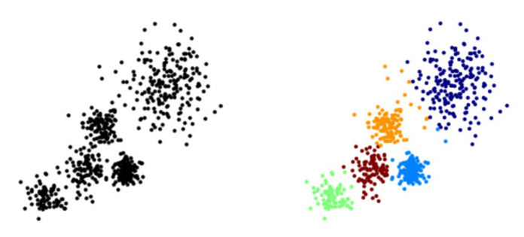
The K Means Algorithm
- Choose a number of Clusters “K”
- Randomly assign each point to a cluster
- Until clusters stop changing, repeat the following:
- For each cluster, compute the cluster centroid by taking the mean vector of points in the cluster
- Assign each data point to the cluster for which the
centroid is the closest

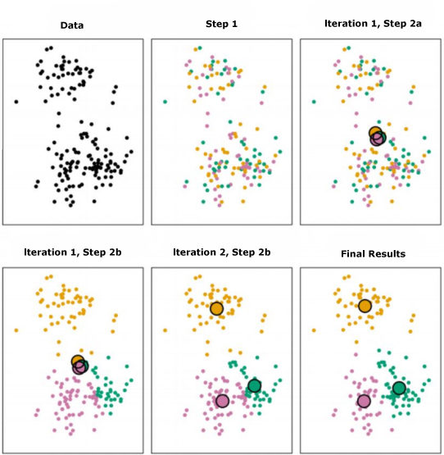

Choosing a K Value
- There is no easy answer for choosing a “best” K value
- One way is the elbow method
First of all, compute the sum of squared error (SSE) for some values of k (for example 2, 4, 6, 8, etc.).
The SSE is defined as the sum of the squared distance between each member of the cluster and its centroid

If you plot k against the SSE, you will see that the error decreases as k gets larger; this is because when the number of clusters increases, they should be smaller, so distortion is also smaller.
The idea of the elbow method is to choose the k at which the SSE decreases abruptly.
This produces an "elbow effect" in the graph, as you can see in the following picture:

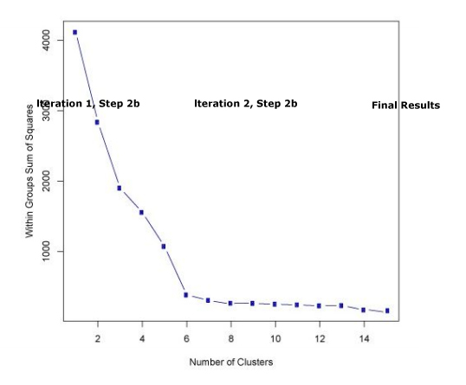

# Importing the libraries
import numpy as np
import matplotlib.pyplot as plt
import pandas as pd

# Importing the dataset
dataset = pd.read_csv('Mall_Customers.csv')
X = dataset.iloc[:, [3, 4]].values
# y = dataset.iloc[:, 3].values

# Splitting the dataset into the Training set and Test set
"""from sklearn.model_selection import train_test_split
X_train, X_test, y_train, y_test = train_test_split(X, y, test_size = 0.2, random_state = 0)"""

# Feature Scaling
"""from sklearn.preprocessing import StandardScaler
sc_X = StandardScaler()
X_train = sc_X.fit_transform(X_train)
X_test = sc_X.transform(X_test)
sc_y = StandardScaler()
y_train = sc_y.fit_transform(y_train)"""

# Using the elbow method to find the optimal number of clusters
from sklearn.cluster import KMeans
wcss = []
for i in range(1, 11):
kmeans = KMeans(n_clusters = i, init = 'k-means++', random_state = 42)
kmeans.fit(X)
wcss.append(kmeans.inertia_)
plt.plot(range(1, 11), wcss)
plt.title('The Elbow Method')
plt.xlabel('Number of clusters')
plt.ylabel('WCSS')
plt.show()

# Fitting K-Means to the dataset
kmeans = KMeans(n_clusters = 5, init = 'k-means++', random_state = 42)
y_kmeans = kmeans.fit_predict(X)

# Visualising the clusters
plt.scatter(X[y_kmeans == 0, 0], X[y_kmeans == 0, 1], s = 100, c = 'red', label = 'Cluster 1')
plt.scatter(X[y_kmeans == 1, 0], X[y_kmeans == 1, 1], s = 100, c = 'blue', label = 'Cluster 2')
plt.scatter(X[y_kmeans == 2, 0], X[y_kmeans == 2, 1], s = 100, c = 'green', label = 'Cluster 3')
plt.scatter(X[y_kmeans == 3, 0], X[y_kmeans == 3, 1], s = 100, c = 'cyan', label = 'Cluster 4')
plt.scatter(X[y_kmeans == 4, 0], X[y_kmeans == 4, 1], s = 100, c = 'magenta', label = 'Cluster 5')
plt.scatter(kmeans.cluster_centers_[:, 0], kmeans.cluster_centers_[:, 1], s = 300, c = 'yellow', label = 'Centroids')
plt.title('Clusters of customers')
plt.xlabel('Annual Income (k$)')
plt.ylabel('Spending Score (1-100)')
plt.legend()
plt.show()

Natural Language Processing

# Importing the libraries
import numpy as np
import matplotlib.pyplot as plt
import pandas as pd

# Importing the dataset
dataset = pd.read_csv('Restaurant_Reviews.tsv', delimiter = '\t', quoting = 3)

# Cleaning the texts
import re
import nltk
nltk.download('stopwords')
from nltk.corpus import stopwords
from nltk.stem.porter import PorterStemmer
corpus = []
for i in range(0, 1000):
review = re.sub('[^a-zA-Z]', ' ', dataset['Review'][i])
review = review.lower()
review = review.split()
ps = PorterStemmer()
review = [ps.stem(word) for word in review if not word in set(stopwords.words('english'))]
review = ' '.join(review)
corpus.append(review)

# Creating the Bag of Words model
from sklearn.feature_extraction.text import CountVectorizer
cv = CountVectorizer(max_features = 1500)
X = cv.fit_transform(corpus).toarray()
y = dataset.iloc[:, 1].values

# Splitting the dataset into the Training set and Test set
from sklearn.model_selection import train_test_split
X_train, X_test, y_train, y_test = train_test_split(X, y, test_size = 0.20, random_state = 0)

# Fitting Naive Bayes to the Training set
from sklearn.naive_bayes import GaussianNB
classifier = GaussianNB()
classifier.fit(X_train, y_train)

# Predicting the Test set results
y_pred = classifier.predict(X_test)

# Making the Confusion Matrix
from sklearn.metrics import confusion_matrix
cm = confusion_matrix(y_test, y_pred)

